Hens and Chicks

How to play:
There are a few chicks and one hen. The hen is trying to catch all the chicks. Chicks have some safe spots around the area. If the Hen catches the chicks then the chicks becomes a hen. Also if you stay in the safe spot longer than 30 seconds you become a Hen!

Rules:
- There must be 3 or more players.
- There must be a few safe spots around the area.
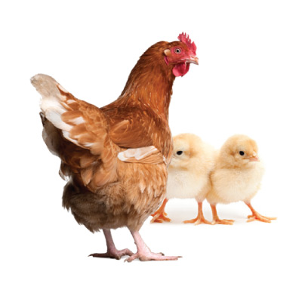
- You are not allowed to push people out of the safe spot.
Equipment:
- Hula-hoops (or just an area to be a safe spot such as a tree).

