Hopscotch
How to play:
Use your chalk to draw a hopscotch grid. Number each square from one to nine. Throw your bean bag on number one then hop on all the squares using one foot in each square. When you reach home hop back the other way and pick up the beanbag. Repeat this pattern with all the squares.
Materials:
One beanbag and some chalk
Rules:
- Hop on one leg
- One foot in each square at all times
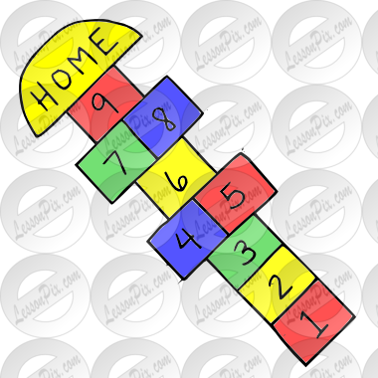
- If the bean bag misses the square you were meant to land on, it becomes the other persons turn.

Hopscotch grid :

