Ninja

How to play
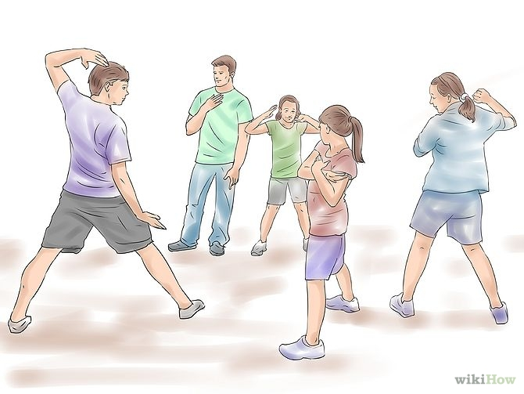
Stand in a circle with 3 people or more. The leader says “bow to the Sensei”. Then the countdown begins and each player must strike a pose and go for the player next to them by swiping there hand. If the person on the other side moves there out and if you get the person next to you before the person on the other side moves the person that was hit is in and if that person hits someone he/she is the winner.

Rules:
- One person can swipe at a time.
- The leader tries to swipe the people’s hands.

