Red light! Green light!

How to play:

The person who is in is called the traffic light. When the traffic light says green light you have to run or walk. If the traffic light says red light you have to freeze. If the traffic light catches you moving you have to go back to the start.

Rules:
- You have to start on a line far away from the person who is the traffic light.
- When the person calls out ‘green light’ walk.
- When the person calls out ‘red light’ freeze!
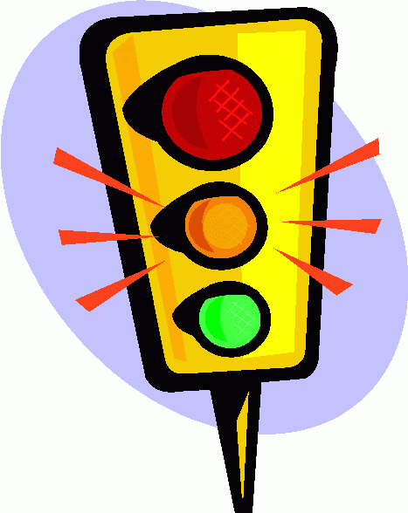
- You can’t push anyone.
- The traffic light can’t walk.
- You have to try and tip the traffic light without them noticing you.

People:
You can play with 3 or more people!

