HOW TO PLAY:
SHADOW TAG
- One Person is in.
- The Person who is in has to chase someone’s shadow.
- The person who is getting chased will be in when the other person steps on their shadow.
Rules of shadow tag:
- Play on a sunny day.
- You cannot pause more than 15 seconds.
- The person whose shadow gets stepped on has to be in.
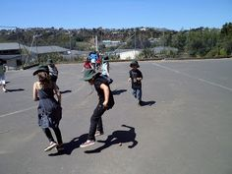
- If you tip someone on the body you are then in.
Number of players: 2 or more players (depends were you play).

